

Software Requirement Specification

FS-SRS-001

Version 1.0

**Revision History**

| Date | Version | Description | Author | Revised by |
| --- | --- | --- | --- | --- |
| 15/4/2021 | 1.0 | First version |  | Minh Tiến |
| 20/04/2021 | 1.0 | Fix button Place Order on product detail | Hữu Thắng | Minh Tiến |
|  |  |  |  |  |
|  |  |  |  |  |
|  |  |  |  |  |

Table of Contents

**1.** **Introduction** 4

**1.1** **Overview** 4

**1.2** **Scope** 4

**2.** **Functional Requirements** 4

**2.1** **Feature/Component #1: MyMobile First screen** 4

2.1.1 First Interfaces 4

**2.2** **Feature/Component #2: MyMobile Onboards Screen** 5

2.2.1 Onboards Interfaces 5

2.2.2 Functional Requirements 8

**2.3.** **Feature/Component #3: MyMobile Home screen** 8

2.3.1. Home Interfaces 8

**2.3.2.** **Functional Requiements** 9

**2.4.** **Feature/Component #4: MyMobile Food Category Screen** 9

2.4.1. Food Category Interfaces 9

2.4.2. Functional Requirements 10

**2.5.** **Feature/Component #5: MyMobile Cart Screen** 10

2.5.1. Cart Interfaces 11

2.5.2. Functional Requirements 11

**2.6.** **Feature/Component #5: MyMobile Product detail Screen** 11

2.6.1. Product-Detail Interfaces 12

2.6.2. Functional Requirements 12

**2.7.** **Feature/Component #6: MyMobile Popular Dished Screen** 12

2.7.1. Popular Dished Interfaces 13

2.7.2. Functional Requirements 14

**2.8.** **Feature/Component #6: MyMobile Chef’s Specials Screen** 14

2.8.1. Chef’s Specials Interfaces 14

2.8.2. Functional Requirements 15

# **Introduction**

## **Overview**

The application allows customers to view details and order products in the store

## **Scope**

Demo version

Demo version is for display purpose only, not link to Database, not link to affiliated sites

Support screen orientation in landscape mode only

Ios screen resolutions: 414x896

Ios test devices: Iphone XS

# **Functional Requirements**

## **Feature/Component #1: MyMobile First screen**

### First Interfaces

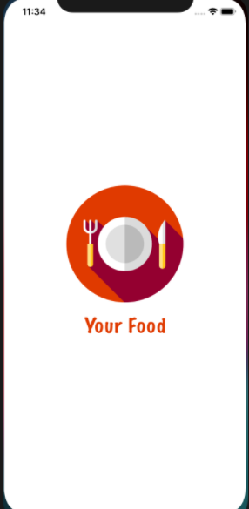

*Image1: First Screen*

## **Feature/Component #2: MyMobile Onboards Screen**

### Onboards Interfaces

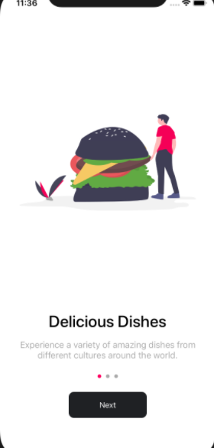

*Image2 : onboard screen 1*

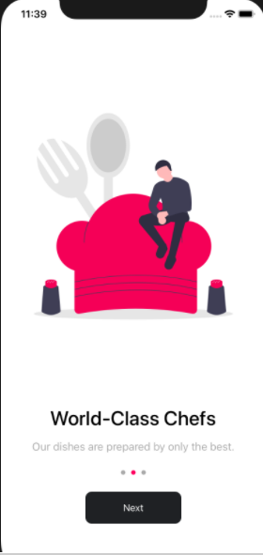

*Image3 : onboard screen 2*

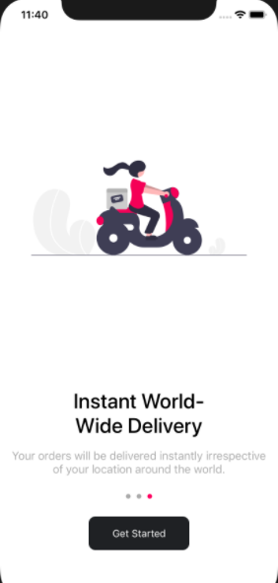

*Image4 : onboard screen 3*

### Functional Requirements

|  |  |  |  |
| --- | --- | --- | --- |
| **Item** | **Description** | **Action** | **Response** |
| **MyMobile onBoard Screen** | MyMobile onBoard Screen has :   * Screen * button ‘Next’ and * 1 button”Get Stared” , * solgan,images logo | N/A | N/A |
| **Image logo ,**  **Slogan** | Display the store's maxim, increasing the customer's eye-catching when entering the application | N/A | N/A |
| **Next button** | On every 1st and 2nd Onboardscreen, there will be a next button | Click on Next button | Convert from this screen to the other screen(screen 1 to screen 2..) |
| **GetStared button** | Appears on the last screen of onboard | Click on GetStared button | After select started. It will switch to the main screen of the application |

## **Feature/Component #3: MyMobile Home screen**

### Home Interfaces

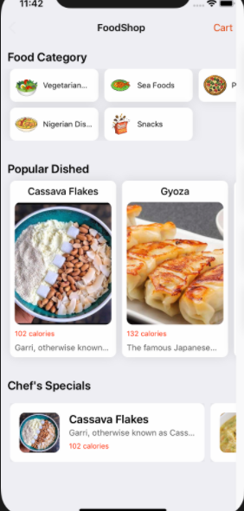

*Image 5 : home screen*

* + 1. **Functional Requiements**

|  |  |  |  |
| --- | --- | --- | --- |
| **Item** | **Description** | **Action** | **Response** |
| **MyMobile Home Screen** | MyMobile Home Screen has :   * Name shop * FoodCategory * Popular Dished * Chef’s Specials * Cart | N/A | N/A |
| **Name shop** | The name of the app | N/A | N/A |
| **FoodCategory** | Display the food items in the shop | When Tap on the Category box on the screen | Show the foods of that category |
| **Cart** | Contains customer orders | Tap cart lable on the home screen | Displays a list of orders that have been placed |
| **Popular Dished** | show the dishes with the most views and orders | Tap on the dish in the popular dishes box | Show that product information |
| **Chef’s Specials** | Display the special dishes that the shop has for sale today | Tap on the dish in the Chef’s Specials box | Show that product information |

## **Feature/Component #4: MyMobile Food Category Screen**

### Food Category Interfaces

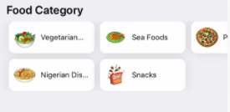

*Image 6 : Food Category*

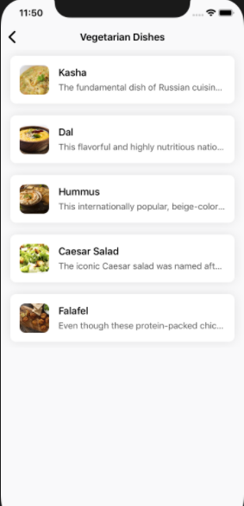

*Image 7 : screen vegetarian dishes*

### Functional Requirements

|  |  |  |  |
| --- | --- | --- | --- |
| **Item** | **Description** | **Action** | **Response** |
| **MyMobile Category Interfaces Screen** | MyMobile Category Interfaces Screen has :   * Names of menu items available in the store | Tap on any category box | Show products in that category |
| **List of dishes** | Dishes in the selected list | Tap on any Dishes in the selected list in the category box | Show that product information |

## **Feature/Component #5: MyMobile Cart Screen**

### Cart Interfaces

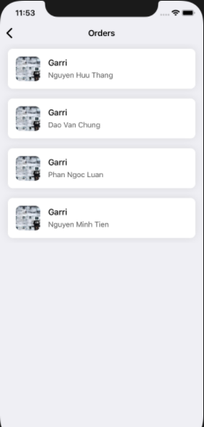

*Image 8 : Cart screen*

### Functional Requirements

|  |  |  |  |
| --- | --- | --- | --- |
| **Item** | **Description** | **Action** | **Response** |
| **MyMobile Cart Screen** | MyMobile Cart Interfaces Screen has :   * Dishes Name * Customer Name | Tap on any oder | Display information about that product |

## **Feature/Component #5: MyMobile Product detail Screen**

### Product-Detail Interfaces

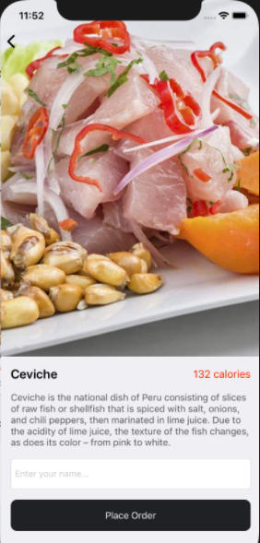

*Image 9 : product detail screen*

### Functional Requirements

|  |  |  |  |
| --- | --- | --- | --- |
| **Item** | **Description** | **Action** | **Response** |
| **MyMobile Product-Detail Screen** | MyMobile Product-Detail Interfaces Screen has :   * Dishes images * Dishes name * Dishes Price * Detailed Product Description * Lable Name Order * Button Order | Enter customer name  Tap on button Place Oder | Display information about that product  Customer's name will be transferred to the shopping cart |

## **Feature/Component #6: MyMobile Popular Dished Screen**

### Popular Dished Interfaces

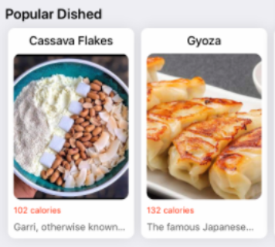

*Image 10 : Popular Dished screen*



*Image 11 : product detail screen*

### Functional Requirements

|  |  |  |  |
| --- | --- | --- | --- |
| **Item** | **Description** | **Action** | **Response** |
| **MyMobile Popular Dished Screen** | * Display information about the most viewed and purchased products | Tap on any product on Popular Dishedbox | Display information about that product |

## **Feature/Component #6: MyMobile Chef’s Specials Screen**

### Chef’s Specials Interfaces

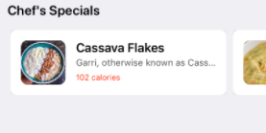

*Image 12 : Chef’s Specials screen*



*Image 13 : product detail screen*

### Functional Requirements

|  |  |  |  |
| --- | --- | --- | --- |
| **Item** | **Description** | **Action** | **Response** |
| **MyMobile Chef’s Specials Screen** | MyMobile Chef’s SpecialsScreen has :   * List of items that will be sold today | Tap on any product on Chef’s Specialsbox | Show that product information |

***--------- End of Document ----------***